Q1.
Answer is B.

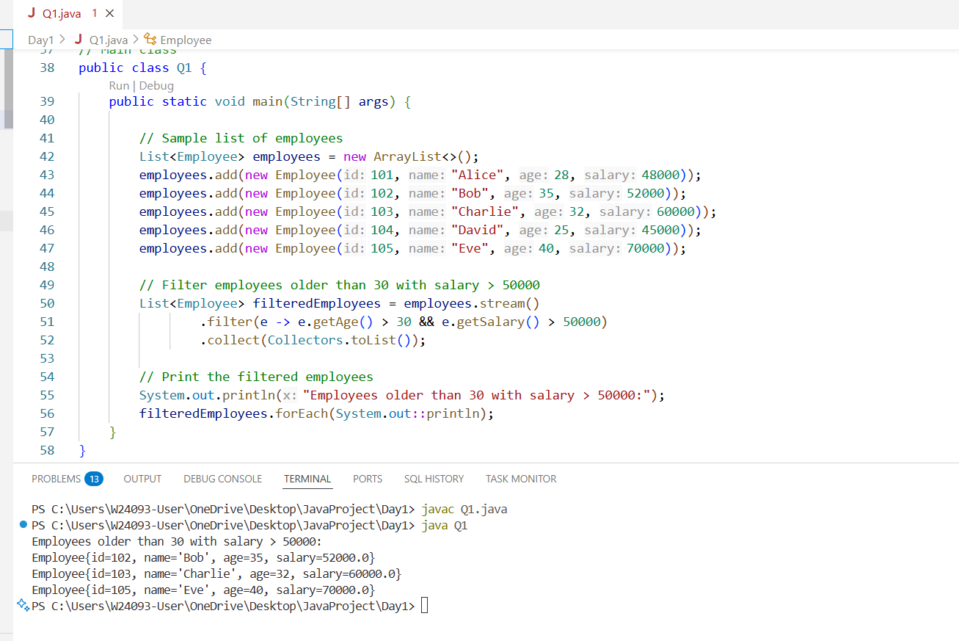

A: Works correctly, but can be slightly optimized.

B: Correct.

C: Incorrect. Will include employees who satisfy only one of the conditions.

D: Incorrect.

Q2.
Answer is A.

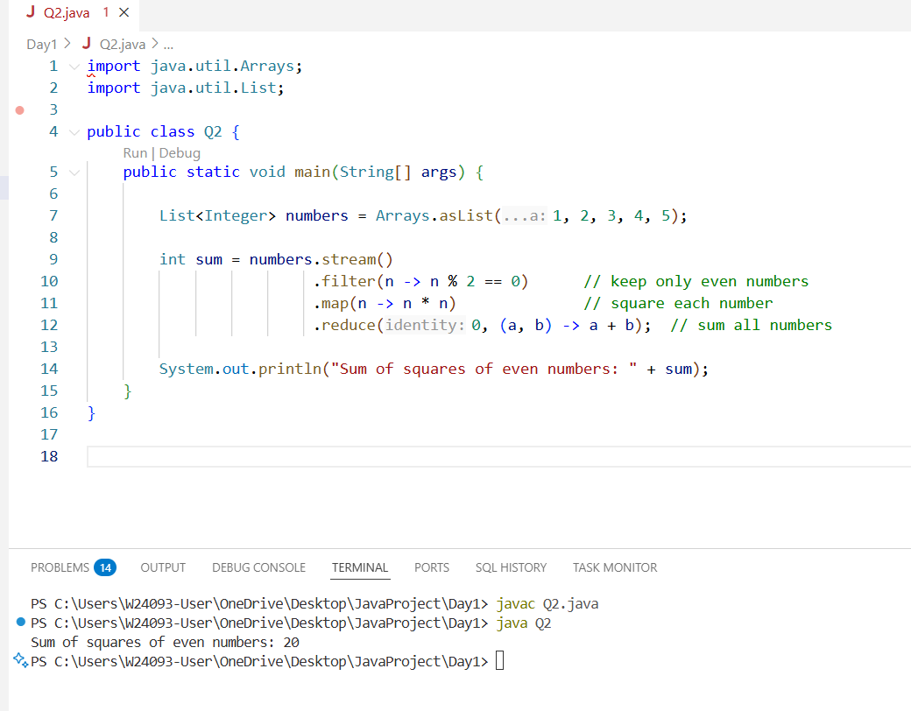

Final answer is 20.

A: Correct.

B: Incorrect.

C: Incorrect. sum of all numbers squared

D: Incorrect. sum of all numbers, not squared

Q3.
Answer is A.

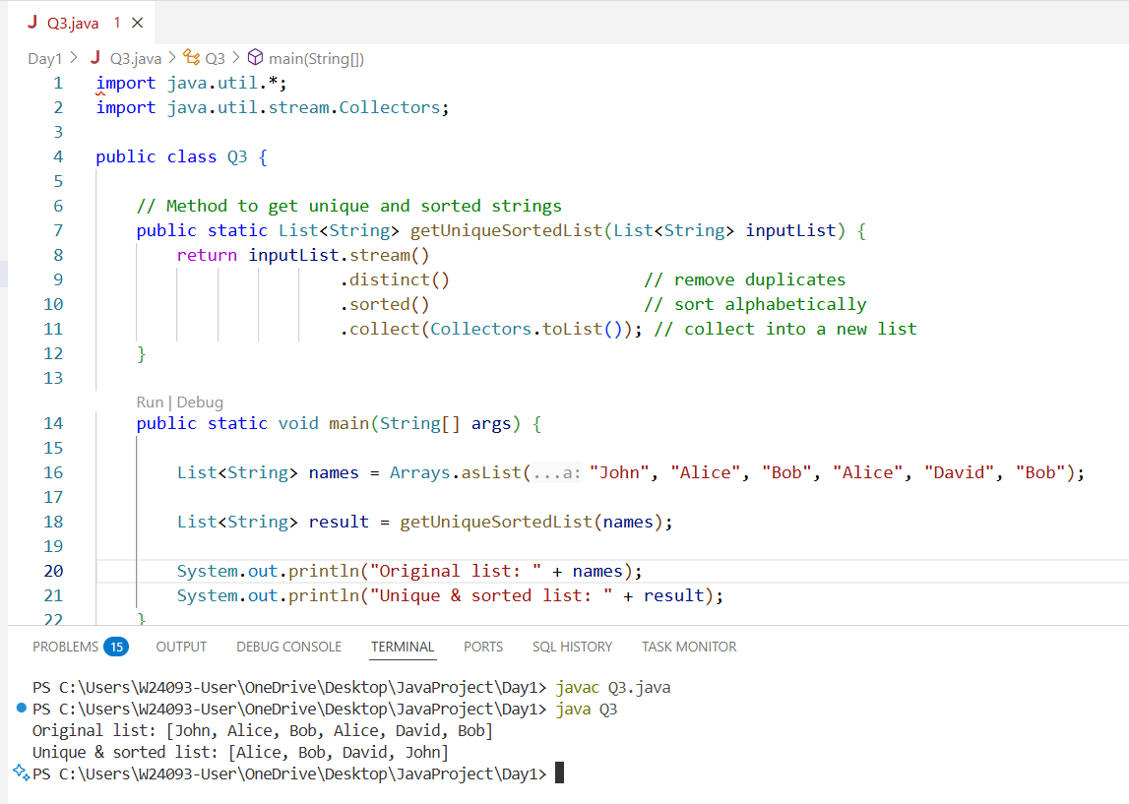

A: Correct. a unique, alphabetically sorted list.

B: Works, but less efficient.

C: It works, but it’s inefficient and verbose compared to Option A.

D: Incorrect.

Q4.
Answer is A.

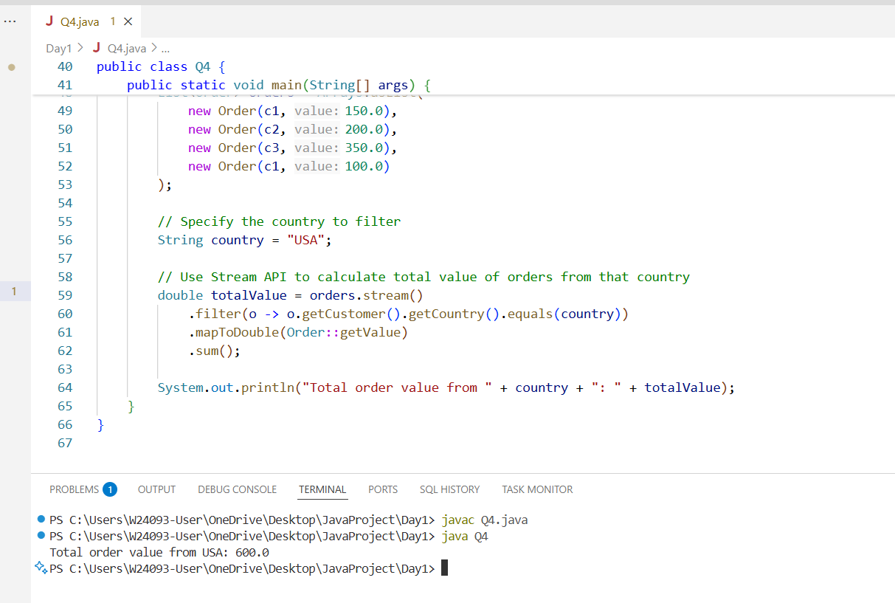

A: Correct and efficient.

B: Also correct but less efficient.

C: Incorrect.

D: Work but less readable.

Q5.
Answer is D.

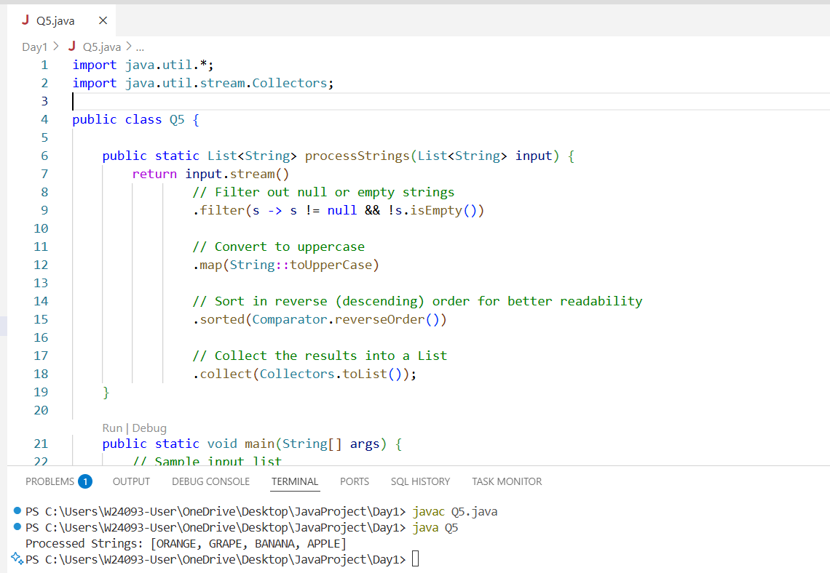

A: There’s only one simple lambda (filter), and it already uses String::toUpperCase where appropriate. No extra method references would improve readability here.

B: Streams make the code concise and declarative. Using a for-loop would make it longer and less maintainable.

C: Unnecessary unless processing very large lists and thread safety/performance analysis confirms the need. Readability would also suffer.

D: Improves clarity, communicates sorting intention clearly, and simplifies maintenance.

Q6.
Answer is A.

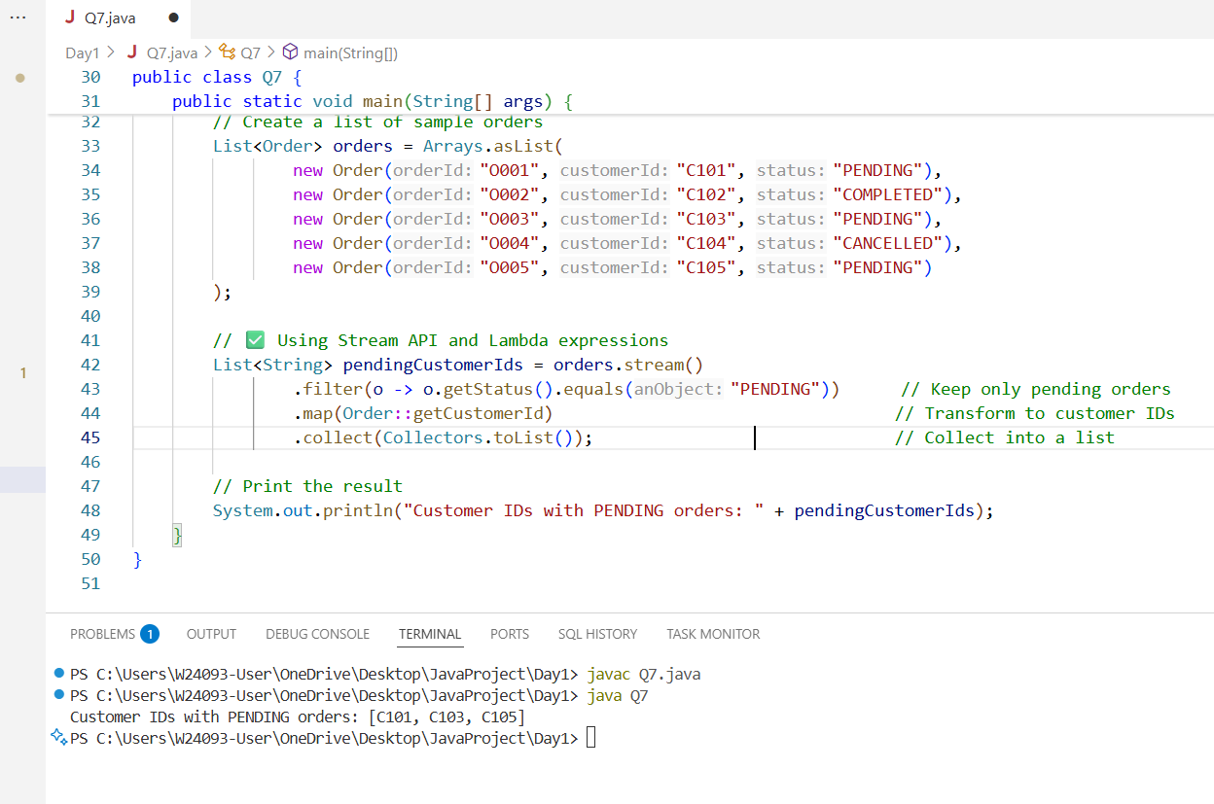

A: Correct. Readable, efficient, and follows proper Stream API usage.

B: Incorrect.

C: Invalid syntax and logic.

D: Wrong order of operations.

Q7.
Answer is A.

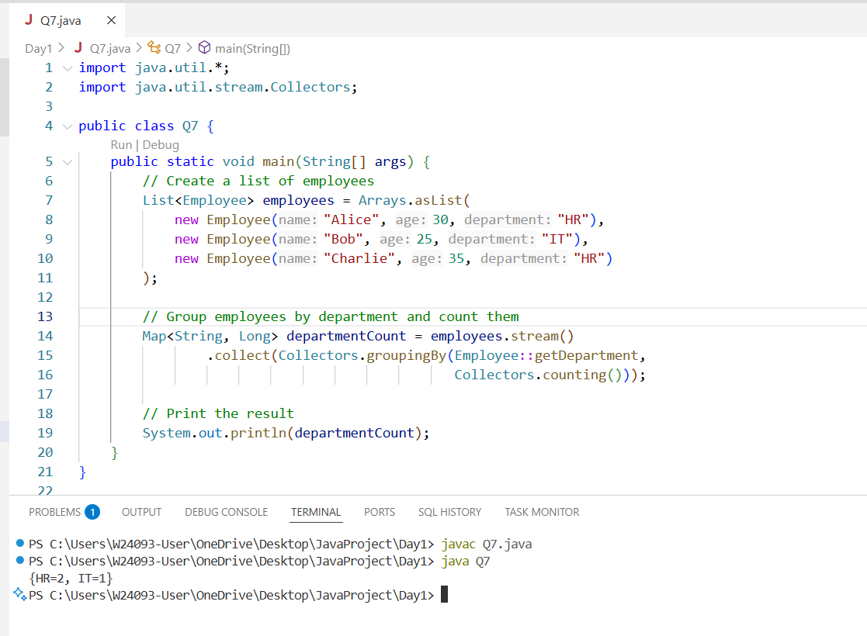

A: Correct.

B: Incorrect.

C: Wrong, HR has 2 employees.

D: No null values used, code is safe.

Q8.
Answer is A & D.

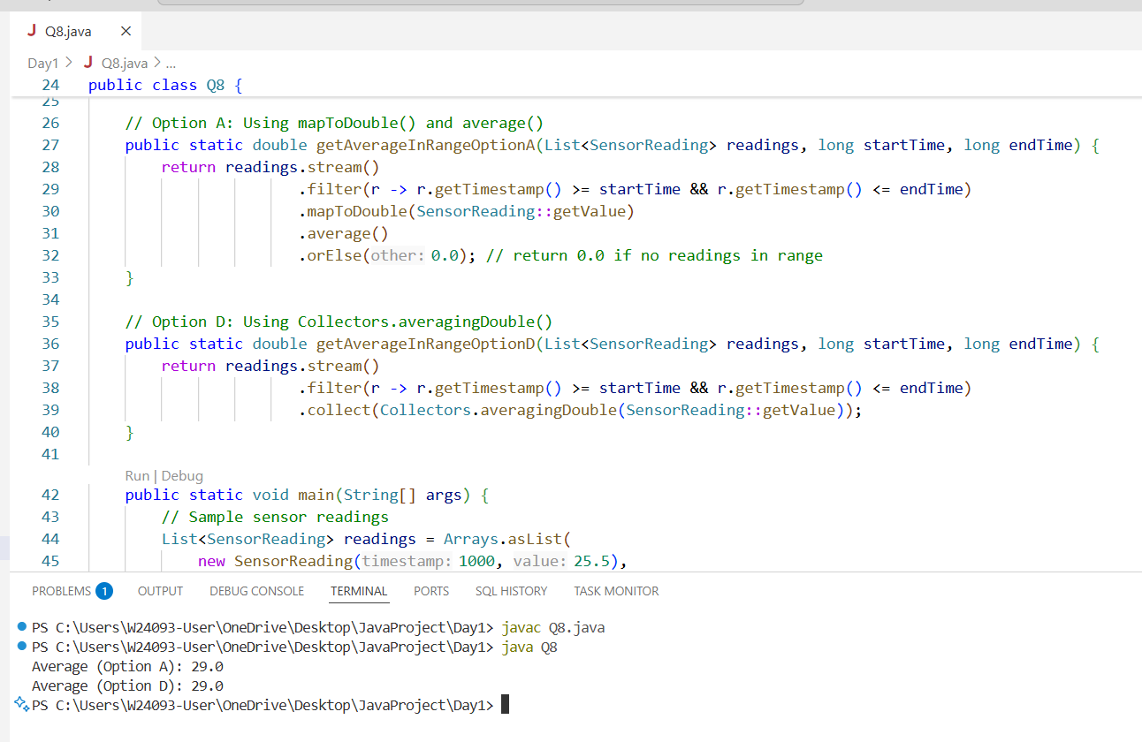

A: Correct. Safe, uses primitive streams, handles empty streams

B: Incorrect. Divides by total size, wrong average.

C: Incorrect. Same as B, unnecessary parallelism.

D: Correct. Clean and readable.

